Introduction to Porsche

Who hasn't heard of Porsche? In 2006 it won the most prestigious automobile brand for over 70 years of excellence and dedication to the four-wheel god. Porsche is a renowned automobile manufacturer that specializes mainly in producing sports cars. The German automobile maker has succeeded in producing sports cars that are known for performance, quality, and reliability. Above all, the Porsche is popular for producing prestigious sports cars that can be used for everyday driving.

The company was founded by Ferdinand Porsche, who was the chief engineer at Mercedes-Benz. He later incorporated his personal engineering plant, where he had developed numerous designs for the ‘People’s Car’ or popularly known as the ‘Volkswagen’. By 1931, Ferdinand incorporated a company under his own name: ‘Porsche’.

Since he was the engineer for the first Volkswagen, the first Porsche created was manufactured from the machinery of the VW Beetle. In 1938, the first Porsche known as the ‘Porsche 64’ was released by the company. The vehicle gained a lot of popularity and this was the start of the successful time in the history of Porsche.

n the 40s, due to the impending war, Porsche was responsible for creating several designs for heavy tanks and had to cease its production because of the Volkswagen plant being destroyed. However, in 1947, the company returned to producing vehicles and designed a new Grand Prix racing car in Gmund, Austria. A year later, Ferdinand’s son Ferry Porsche built the company’s first sports car, the 356.

The racing car too was created from VW parts and was the first roadster to bear the Porsche name. It was during this time that Porsche also designed its logo, which was based on the ‘Coat of Arms of the Free People State’. In 1951, Ferdinand Porsche died due to a heart stroke and the company was taken over by his son, Ferry.

That same year, the 356 achieved its first international win: the 1100 CC class. By 1953, the Fuhrman engine was presented in the most famous vehicle, The Porsche 550 Spyder. This 1.5L four-cylinder engine could deliver an impressive 110 BHP that became an immediate success in the automotive industry. Three years later, the company celebrated its 25th anniversary and the 10,000th Porsche vehicle hit the streets.

Car model

Porsche 356 is commonly known as the first sports car built by Ferry Porsche and its considered by Porsche to be its first production model. The 356 is a four-cylinder, air-cooled, rear-engine, rear-wheel drive car with unitized pan and body construction. The chassis was a completely new design as was the 356's body which was designed by Porsche employee Erwin Komenda, while certain mechanical components including the engine case and some suspension components were based on and initially sourced from Volkswagen.

The first 356 was road certified in Austria on June 8, 1948, and was entered in a race in Innsbruck where it won its class. Porsche re-engineered and refined the car with a focus on performance. Fewer and fewer parts were shared between Volkswagen and Porsche as the 1950s progressed. By the early 1950s the 356 had gained some renown among enthusiasts on both sides of the Atlantic for its aerodynamics, handling, and excellent build quality. The class win at Le Mans in 1951 was a factor.

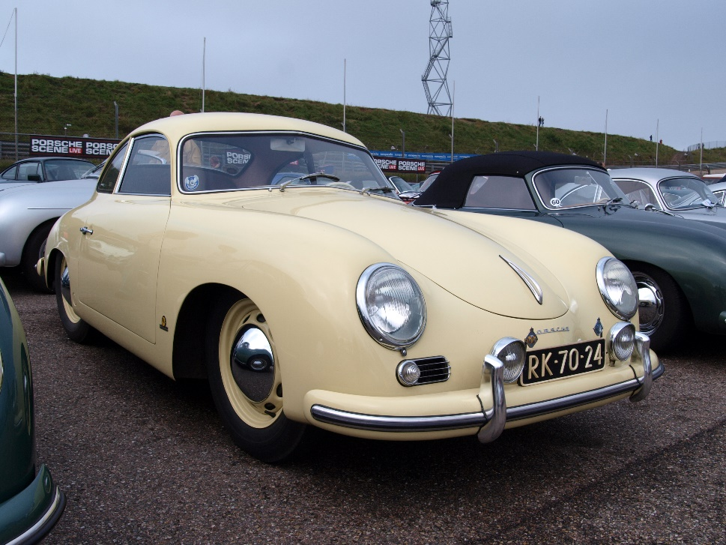

**1954 Porsche 365**

Car accessory

Porsche expresses personal freedom and individuality in personalizing our vehicles. Inspired by the first Roadster, Porsche introduces Tequipment. Porsche Tequipment allows you to assert your own individuality and creativity; Tequipment range of components offers an almost unlimited scope for personalizing your very own Porsche.

Car Pictures

718 Cayman

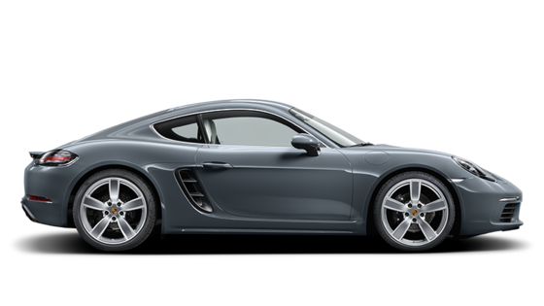

718 Boxster

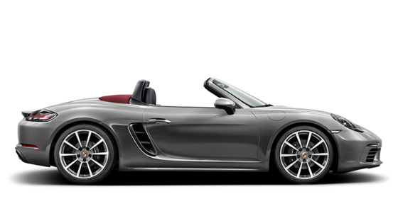

718 Cayman GTS

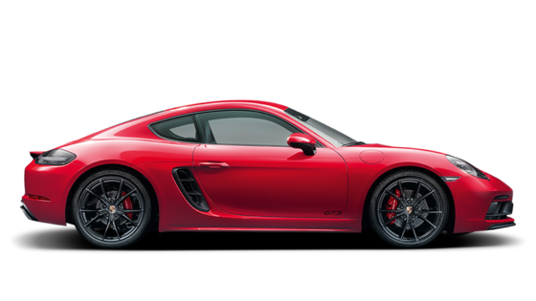

911 Carrera

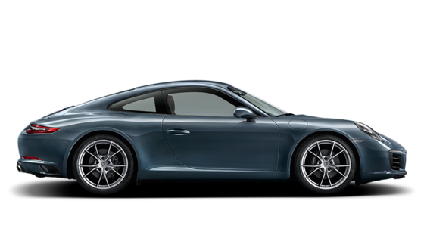

911 Turbo

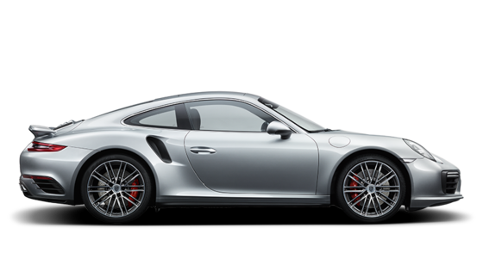

911 Carrera GTS

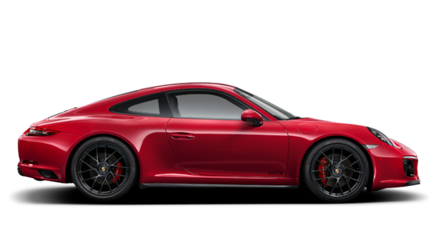

Feedback form